A258-Afr-Egy-Ushabti-3rd Intermediate Period-21st Dynasty-1069-945 BCE-Overseer Figure

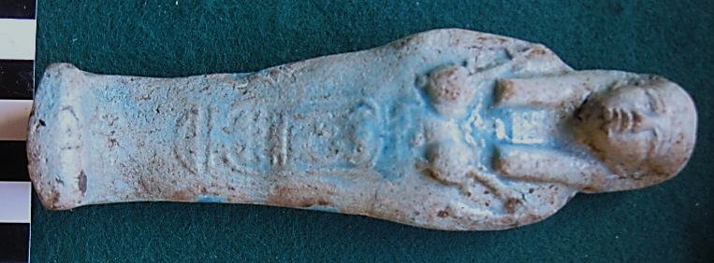

**Case No.: 2**

**Formal Label:** Ushabti-3rd Intermediate Period-21st Dynasty-1069-945 BCE-Overseer Figure

**Display Description: Hands crossed, opposite unsleeved, arms not indicated. Cartouche vertical down front.** By the Third Intermediate Period (1069-525 BC) numbers of Ushabtis increased dramatically although they became smaller in size. The figures wearing the dress of daily life during the 19th and 20th Dynasties evolved by the 21st Dynasty into ‘overseer’ figures. These are distinguished by carrying whips in their hands. Each ‘overseer’ was supposed to supervise ten mummiform ‘worker’ Ushabtis. The appearance of the whip perhaps suggests that the Ushabtis figures were now being considered as slaves or servants rather than deputies. The inscriptions on Ushabtis of the Third Intermediate Period are usually very brief, only giving the Osiris-name and title of the deceased (Janes 2002).

**Accession Number: A258**

**LC Classification:**

**Date or Time Horizon:** 3rd Intermediate Period-21st Dynasty-1069-945 BCE

**Map, GPS Coordinates:**

**Cultural Affiliation:** 3rd Intermediate Period-21st Dynasty-1069-945 BC

**Medium:** blue glaze

**Dimensions: 151.24 mm; 5.95 in  
Weight: 4 5/8 oz,134 gm**

**Provenance: unknown**

**Condition: original**

**Discussion: Discussion:** The prescribed number of Ushabtis for an individual was 401 comprising one Ushabti for every day of the year and 36 ‘overseer’ figures, one for every 10 workers. Usually made of blue glazed faience, they were rather crudely made in open molds, and the sides and back were usually trimmed flat. The figures were still placed in Ushabti boxes although these were usually more simple in design and devoid of the sometimes lavish decorations of the New Kingdom.

The 3rd Intermediate Period was one of decline and political instability, coinciding with the Late Bronze Age collapse of civilizations in the Near East and Eastern Mediterranean (including the Greek Dark Ages). It was marked by division of the state for much of the period and conquest and rule by foreigners.

**References:**

Aubert, J.-F. et L. Aubert. 1974. *Statuettes Egyptiennes: Chaouabtis, Ouchebtis.* Paris, 1974.

Janes, Glenn. 2002. *Shabtis. A Private View, Ancient Egyptian Funerary Statuettes in European Private Collections.* Paris: Cybèle.

Newberry, Percy E. 1930-1957. *Funerary Statuettes and Model Sarcophagi.*  Le Caire: Impr. de l'Institut français d'archéologie orientale.

Schneider, Hans D. 1977. *Shabtis - An Introduction to the History of Ancient Egyptian Funerary Statuettes. With a Catalogue of the Collection of Shabtis in the National Museum of Leiden*. (3 volumes, Leiden: Rijksmuseum van Oudheden Te Leiden.

Schlögl, Hermann and Andreas Brodbeck. 1990. *Ägyptische Totenfiguren aus öffentlichen und privaten Sammlungen der Schweiz.* Orbis Biblicus et Orientalis, Series Archeologica, 7. Göttingen, Vandenhoeck & Ruprecht; Freiburg Schweiz, Universitätsverlag.